PRM393 – SE1909
Đặng Đức Minh – SA170080
Lab 1:
Ex1:
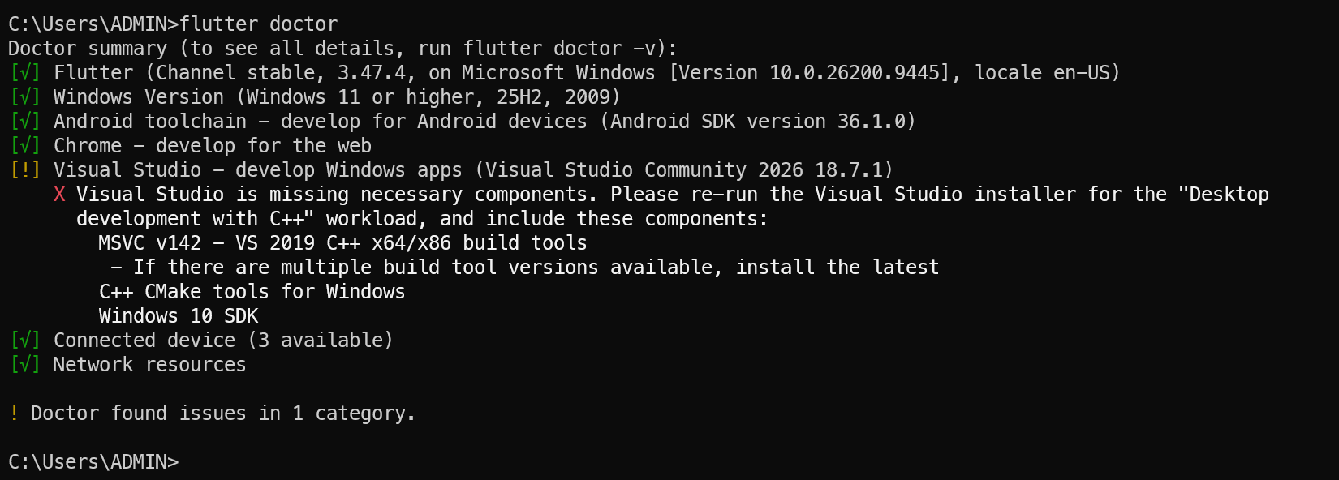 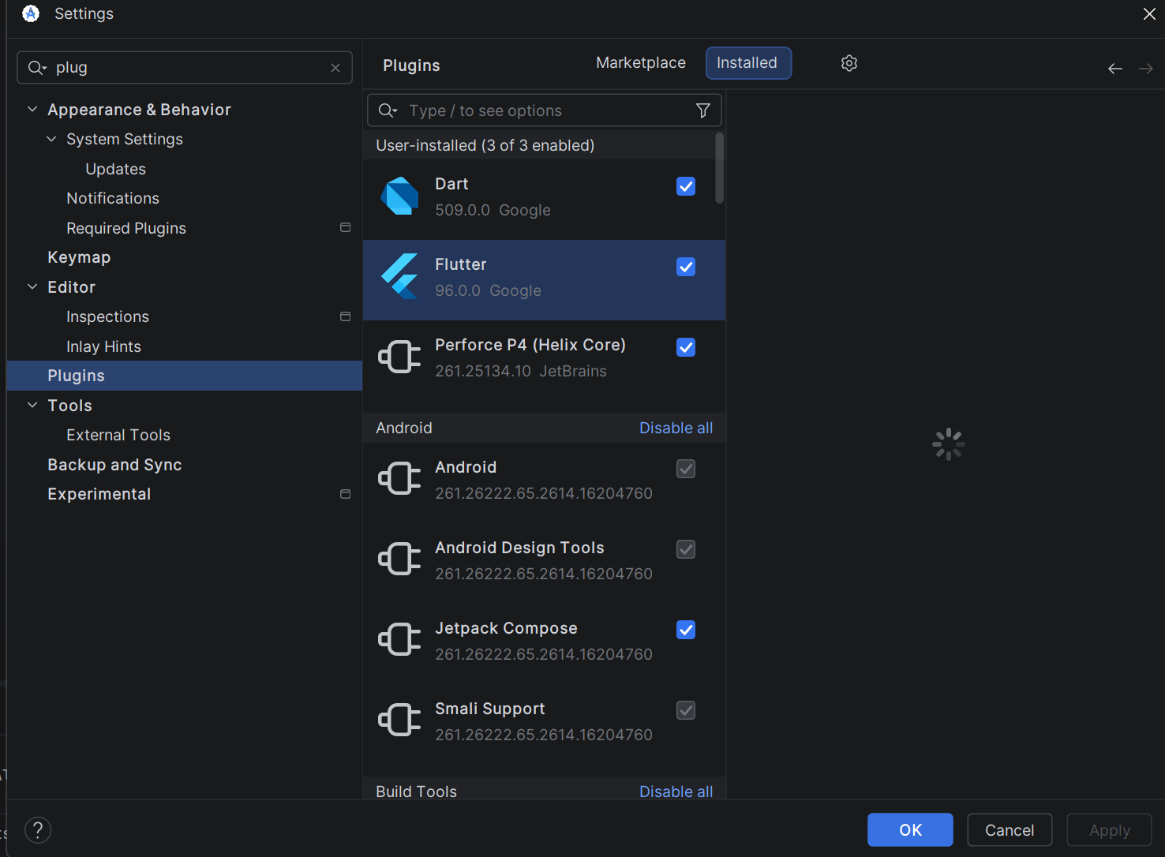Ex2: 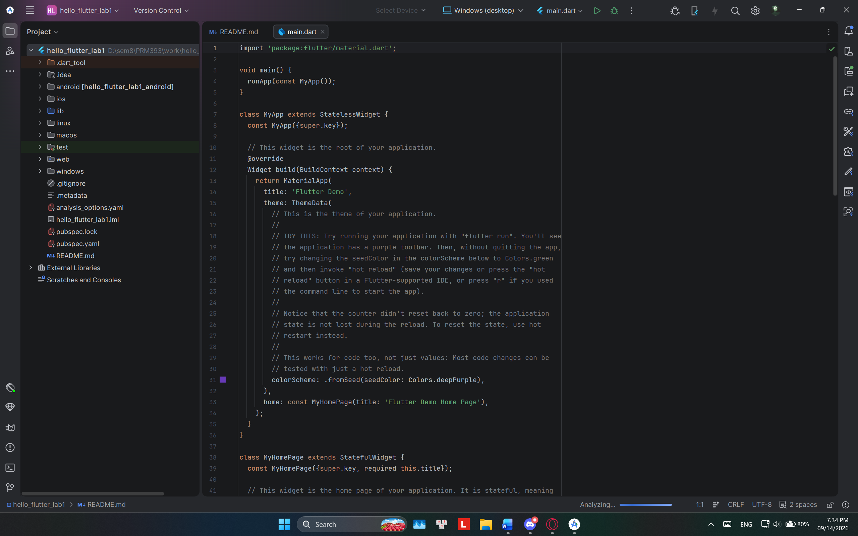 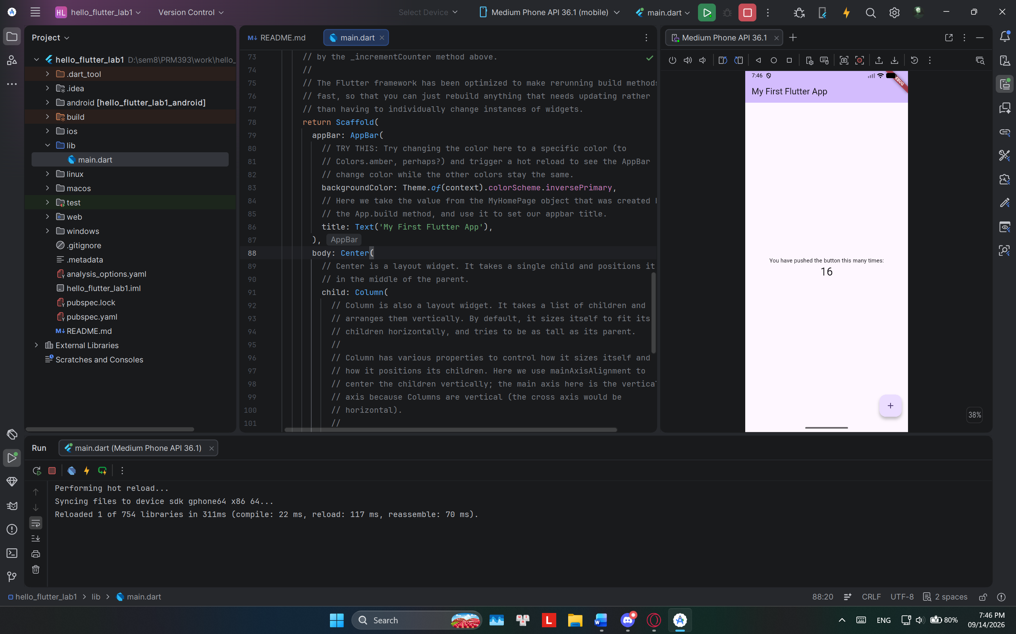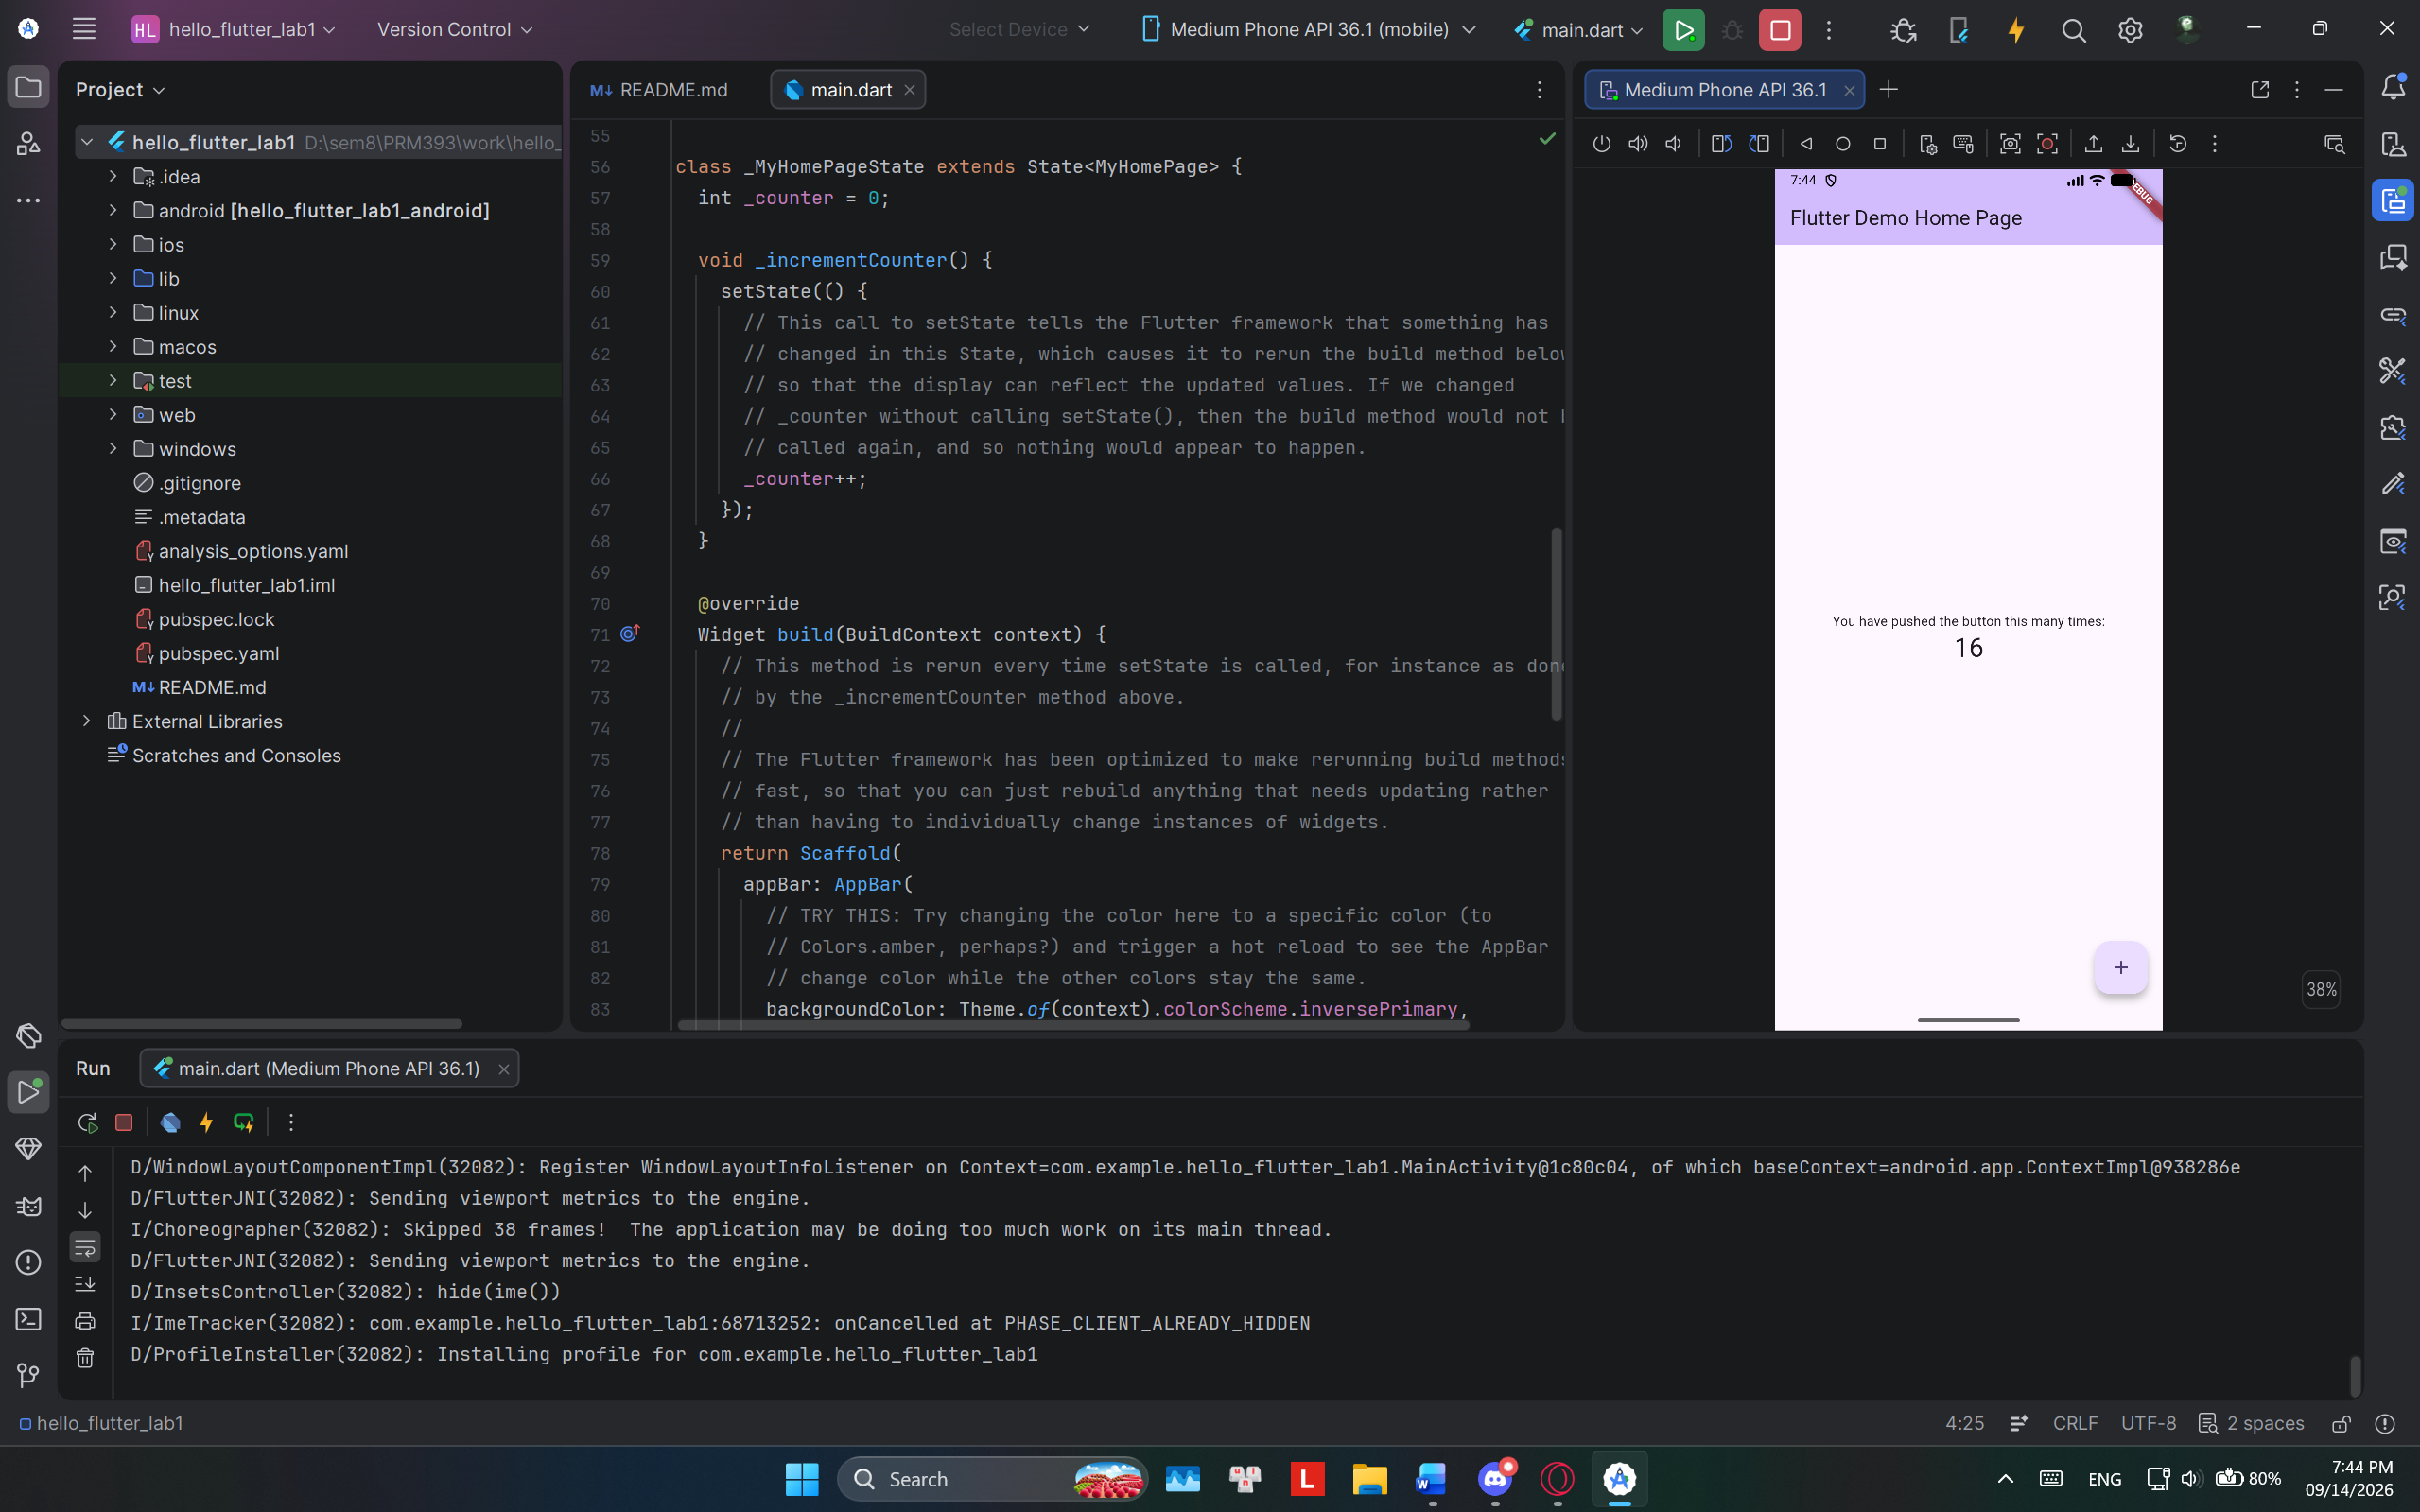
Ex3: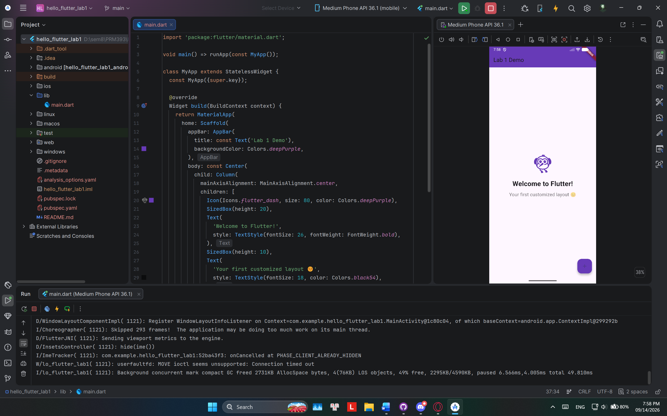 Ex4:

- What is the purpose of the flutter doctor command?
It checks your computer to make sure Flutter, Android Studio, and all required setup tools are properly installed.

- What file acts as the entry point of a Flutter application?
The lib/main.dart file, starting inside the main function.

- Explain the difference between Hot Reload and Hot Restart.
Hot reload updates code changes fast without wiping your app data. Hot restart completely restarts the app and clears all current data back to default.

- How does runApp() build the widget tree?
It receives your root widget, connects it to the Flutter engine, and draws the initial layout on screen.

- Describe how Flutter's architecture enables cross-platform development.
Flutter uses its own built-in canvas renderer to draw pixels directly, so the app looks and runs the same on Android, iOS, and Web without relying on native phone buttons or controls.

